Operational Concept Description (OCD)

Image Processing Platform

Team 04

Name | First Role | Second Role | Third Role
Hao Wu | Requirements Engineer | Software Architect | Implementer
Junran Liu | Operational Concept Engineer | Software Architect | Implementer, Trainer
Meiyi Yang | Project Manager | Life Cycle Plan | Implementer
Vinny DeGenova | IIV & V | Quality Focal Point | Implementer
Xiangchen Zhao | Life Cycle Plan | Prototyper | Implementer
Xinhui Liu | Feasibility Analyst | Operational Concept Engineer | Implementer, Tester
Yifan Liu | Prototyper | Requirements Engineer | Implementer

12/04/2016

Version History
Date | Author | Version | Changes made | Rationale
10/04/16 | Junran Liu | 1.0 | - Finish draft according to our current requirements | - To fit this template form to our team
10/07/16 | Junran Liu | 1.1 | - Modify shared vision | - To fit draft to our current requirements
10/08/16 | Junran Liu | 1.2 | - Modify workflow | - To fit the document to our current requirements
10/10/16 | Junran Liu | 1.3 | - Modify System Boundary | - Delete testing module and training module since they are not external modules
10/14/16 | Junran Liu | 1.4 | - Modify System Boundary and Benefits Chain | - According to feedback from DCR
11/29/16 | Junran Liu | 1.5 | - Modify some figures | - According to feedback from our development process

Table of Contents
Operational Concept Description (OCD) i
Version History ii
Table of Contents iii
Table of Tables iv
Table of Figures v
1. Introduction 1
1.1 Purpose of the OCD 1
1.1 Status of the OCD 1
2. Shared Vision 2
2.1 Overview of the system 2
2.2 Benefits Chain 3
2.3 System Capability Description 3
2.4 System Boundary and Environment 4
3. System Transformation 5
3.1 Information on Current System 5
3.2 System Objectives, Constraints and Priorities 7
3.3 Proposed New Operational Concept 9
3.4 Organizational and Operational Implications 11

Table of Tables
Table 1: The Program Model of Image Processing Platform 2
Table 2: Artifacts 5
Table 3: Capability Goals 7
Table 4: Level of Service Goals 7
Table 5: Relation to Current System 8

Table of Figures
Figure 1: Benefits Chain Diagram 3
Figure 2: System Boundary and Environment Diagram 4
Figure 3: Current Business Workflow 6
Figure 4: Element Relationship Diagram of Image Processing Platform 9
Figure 5: Business Workflows Diagram of Image Recognition 10
Figure 6: Business Workflow Diagram of Retraining 11

Introduction

1.1 Purpose of the OCD

The purpose of this document is to describe one detailed shared visions and goals of the Image Platform Processing. The success-critical stakeholders of this project are Eder Figueroa and Ripple Goyal, as the project owners; the users who have the requirement to classify images, as users; our team 4, as the developers.

Status of the OCD
The status of the OCD is currently at the As-Built version number 1.5 in the delivery phase. All the sections of OCD has been completed according to current requirements.

Shared Vision

Overview of the system

Table 1: The Program Model of Image Processing Platform
Assumptions
- Users are willing to upload images
- It’s more convenient for users to classify images by our system than by themselves
- Our clients will use our system

Stakeholders | Initiatives | Value Propositions | Beneficiaries
- Development Team  - Users  - Clients  - Owners | - Build a new image processing platform  - Divide system into two separate pipelines  - Integration our pipeline into company's current system  - Marketing Campaign  - Users upload images | - An easier way for trainers to train the model  - Scope company’s current system  - An easier way to classify images  - Increase the efficiency to classify images | - Users  - Trainers  - Clients

Benefits Chain
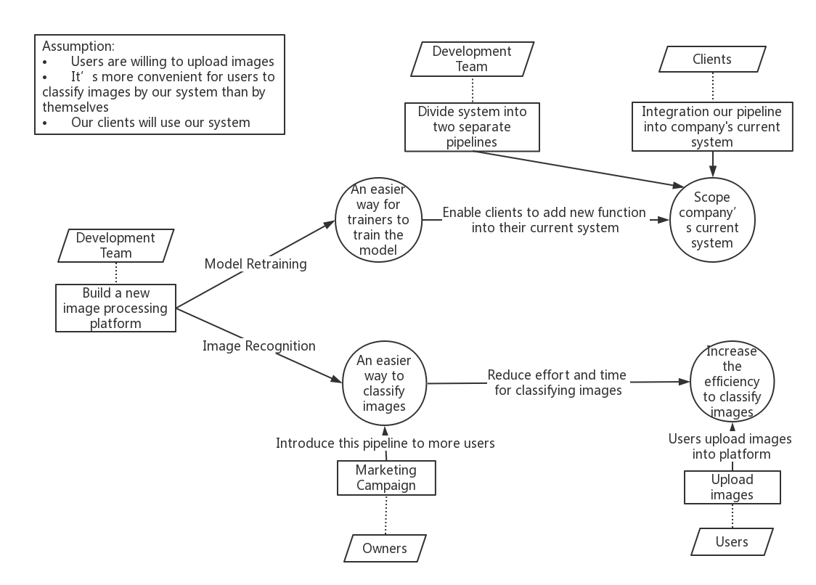
Figure 1: Benefits Chain Diagram

System Capability Description
Our system is an image processing platform, aiming at classifying images into different classes. At first, our model can divide images into 100 classes, including animals, plants, food, electronics and so on. Users can upload images from local directories. Then after pipeline processing, users can get images with labels. Our target users can be regular users who want to try an easier way to classify images. For example, one user can upload several images, then he can get images with different labels.

Besides, our system also provides a way to retrain the model. Trainers can add a new topic and upload related image dataset. After retraining, the new model adds a new class. Meanwhile, trainers can also select one exist topic and upload related image dataset to retrain the model to improve accuracy.

System Boundary and Environment

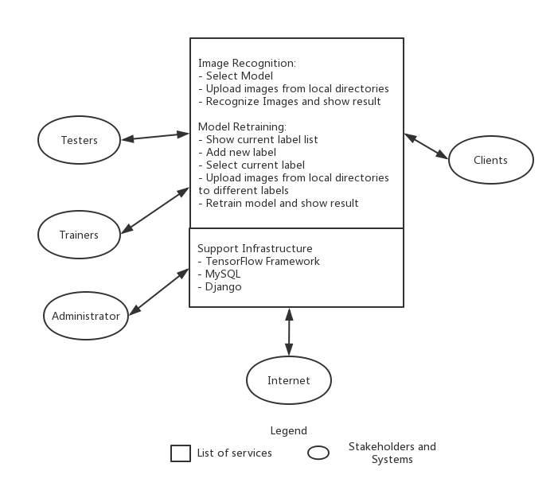
Figure 2: System Boundary and Environment Diagram

System Transformation

Information on Current System

Infrastructure
The company’s current system allows users to intelligently and proactively deploy their security resources in the most effective way to meet their security objectives. This system is implemented by Natural Language Processing pipeline so that this system can mine Twitter in real-time. For example, if one person posts tweets containing some keywords in one specific location, then users will receive alerts from the system and deploy more security resources in this location in advance.

For now, we need to provide a separate system from scratch, as a pipeline for company to scope its system, enabling its system to use images data as well. Our system is a simple system in which users can upload images from local dictionary and get images with class label. Meanwhile, trainers can add a new topic and train the model.

Artifacts
Table 2: Artifacts
Artifact | Description | Requested/ Shown/ Received | Planned Delivery Date
Algorithm Frameworks | Deep Learning frameworks to implement algorithm | Received
Image datasets | Image datasets to train model | Received

Current Business Workflow
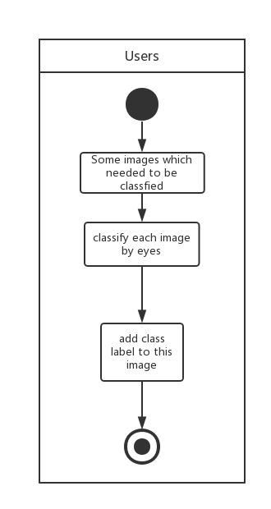
Figure 3: Current Business Workflow

System Objectives, Constraints and Priorities

Capability Goals
Table 3: Capability Goals
Capability Goals | Priority Level
<<OC-1: Upload images: Users are able to upload images from local dictionary. >> | << Must have>>
<<OC-2: Preprocess images: The pipeline can preprocess images. >> | << Must have>>
<<OC-3: Add topic: Trainers can add new topic. >> | << Must have>>
<<OC-4: Train/Retrain the model: The pipeline can retrain the model. >> | << Must have>>
<<OC-5: Show results: The users can see images with labels. >> | << Must have>>
<<OC-6: Classify images: The pipeline can use the model to classify uploaded images. >> | << Must have>>
<<OC-7: Show Training Process Bar: The website can show the process bar. >> | << Could have>>

Level of Service Goals
Table 4: Level of Service Goals
Level of Service Goals | Priority Level | Referred WinWin Agreements
Time to classify each image  (5s) | Low | As a client I can upload an image to the pipeline and see a text along with the initial image
Time to train a new model  (8h) | Low | As a client I can re train the pipeline by giving a new topic and a new set of images
The accuracy of classification  (90%) | High | As a client I can upload an image to the pipeline and see a text along with the initial image

Organizational Goals
OG-: Provide clients a separate pipeline to increase the scope of current system
OG-2: Provide an easier option to classify images

Constraints
CO-1: Zero Monetary Budget: The selected NDI/NCS should be free or no monetary cost.
CO-2: Unix based server: The entire system should be able to run on Unix based server.

Relation to Current System
Since our system is built from scratch, we don’t have current system.
Table 5: Relation to Current System
Capabilities | Current System | New System
Roles and Responsibilities | N/A | - Users can upload images, then they can get original images with labels  - Trainers can train the model
User Interactions | N/A | - Model Retraining  - Image Recognition
Infrastructure | N/A | - Image Processing Platform
Stakeholder Essentials and Amenities | N/A | - Easier way to recognize images  - Easier way to train the model
Future Capabilities | N/A | - Our pipeline can be used to scope company’s current system

Proposed New Operational Concept

Element Relationship Diagram
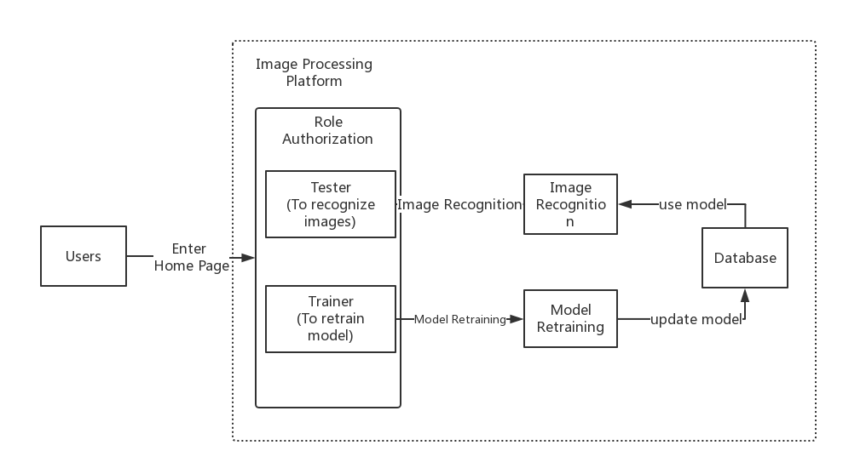
Figure 4: Element Relationship Diagram of
Image Processing Platform

Business Workflows
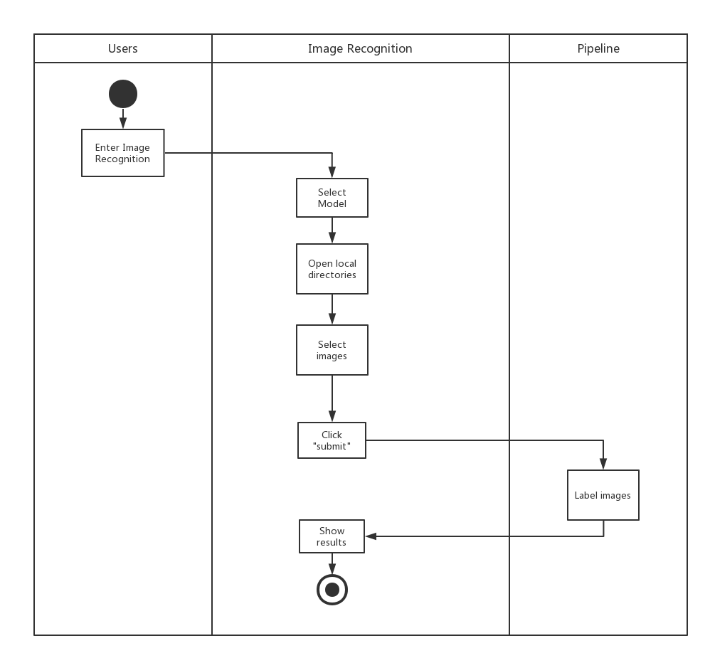

Figure 5: Business Workflows Diagram of Image Recognition
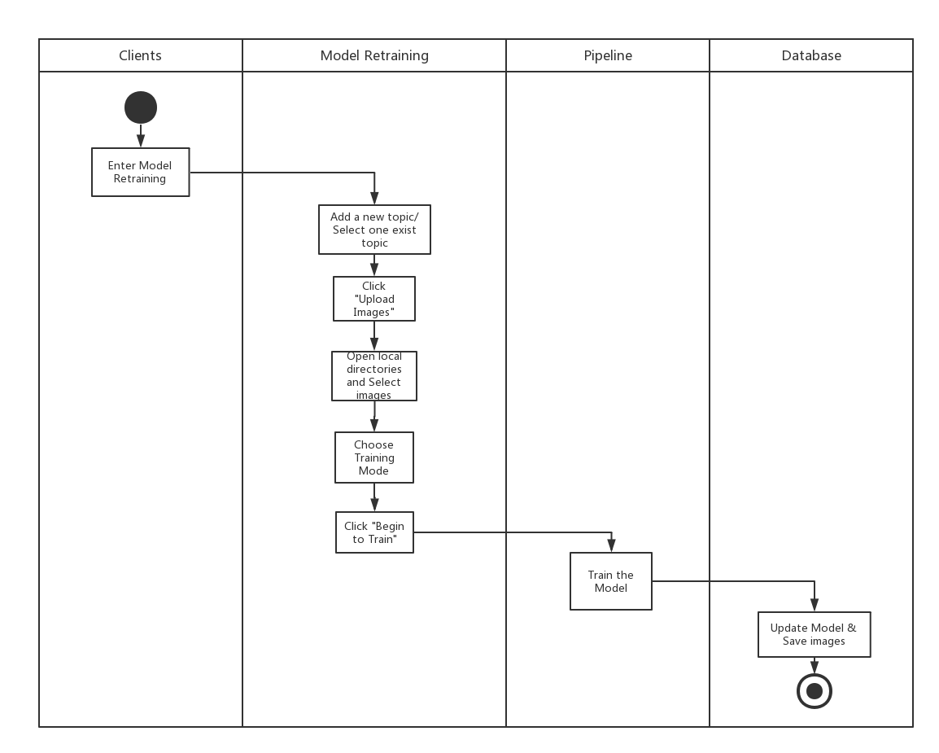
Figure 6: Business Workflow Diagram of Retraining

Organizational and Operational Implications

Organizational Transformations
- The need to hire a new system maintainer to take care of the system
- The need to integration our pipeline to current system

Operational Transformations
- Users need to upload images into our system rather than classify images by eyes

